**Name: Shaunak Deshpande**

**Div.: TY-IC-C**

**Roll. No.: 39**

**GR no.: 11911180**

**Batch.: 2**

**LAB 2:- Feedback Control for Temperature control of Steam heater**

Task 1:- To understand how PID controller work in Manual mode

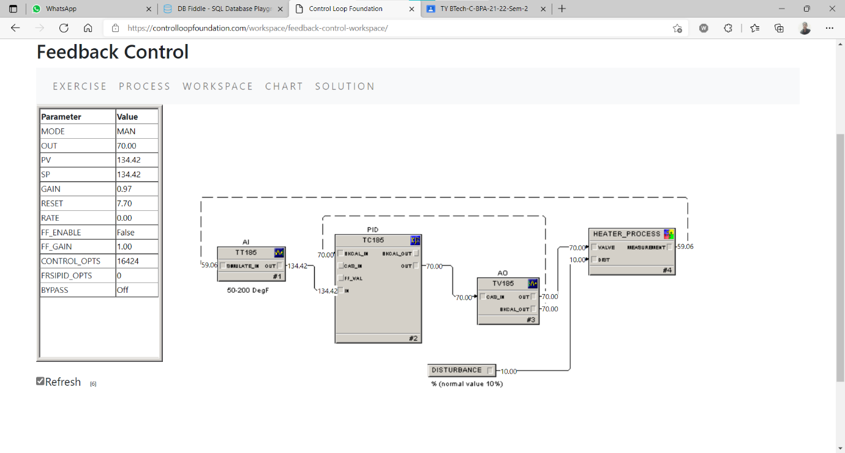

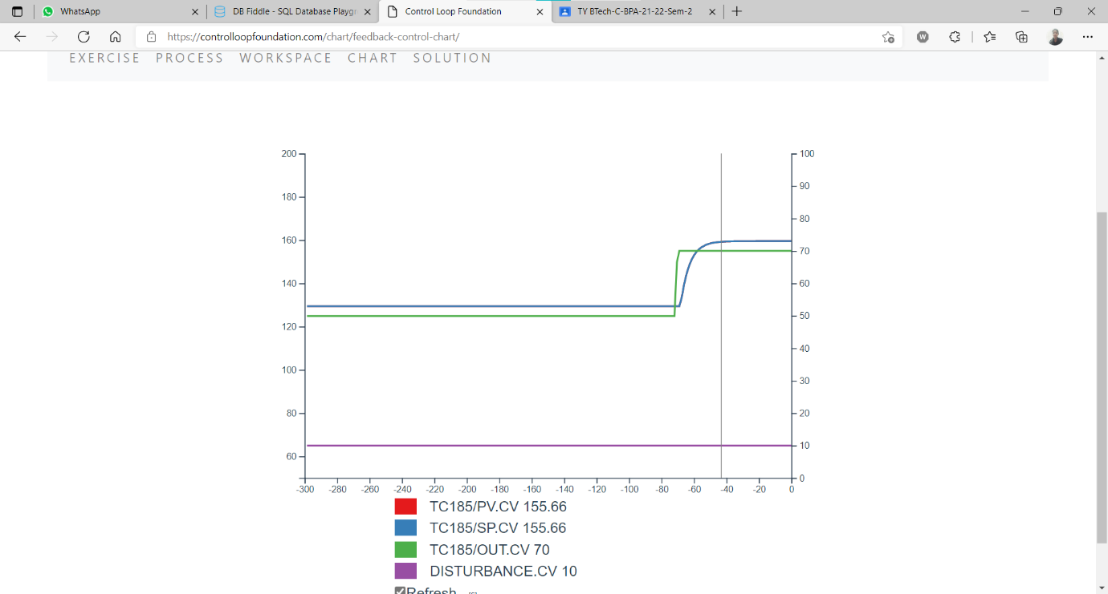

Task 2:- To understand how PID controller work in Auto mode

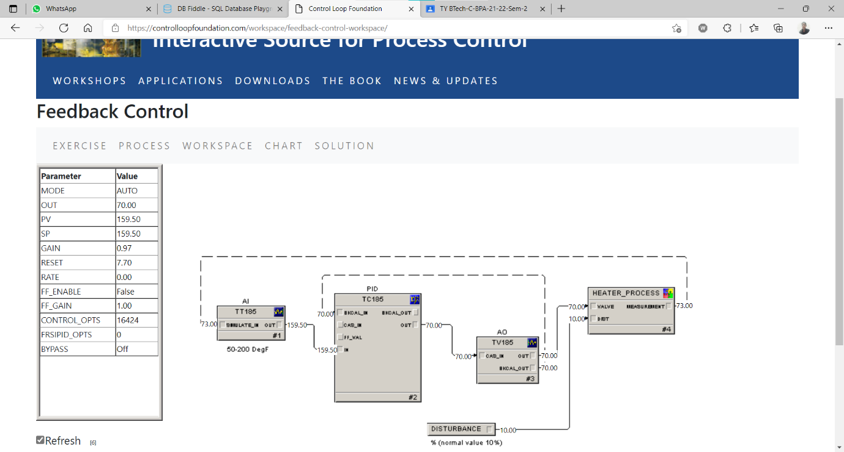

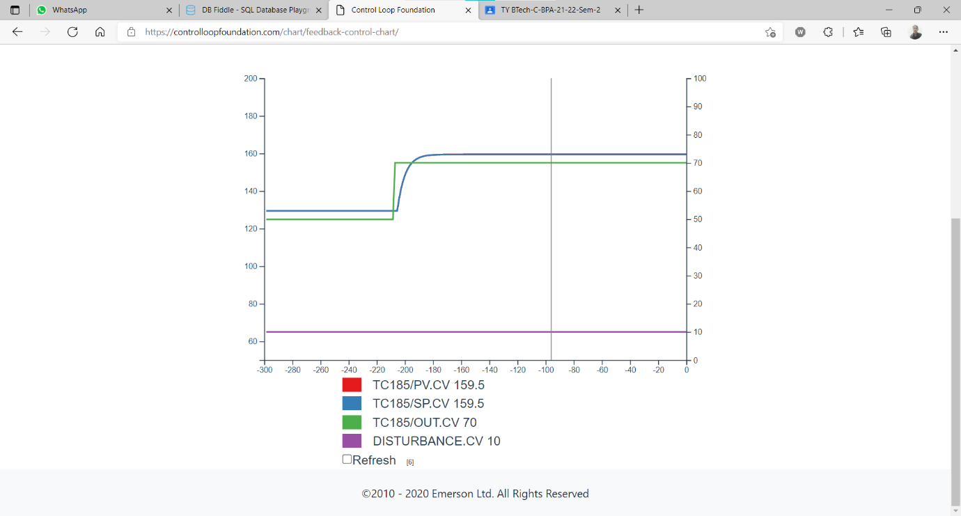

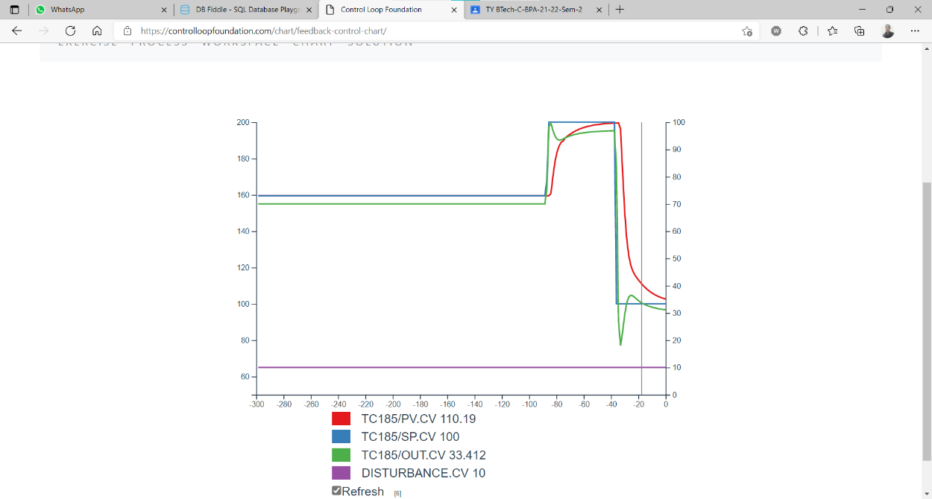

Task 3:- To comprehend how PID controller respond to the disturbances : Setpoint change

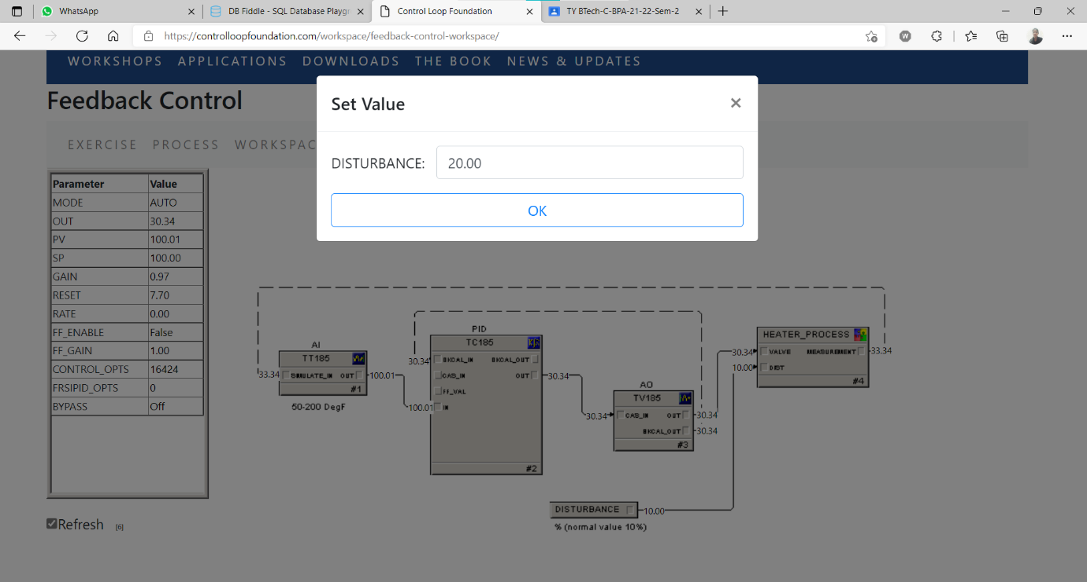

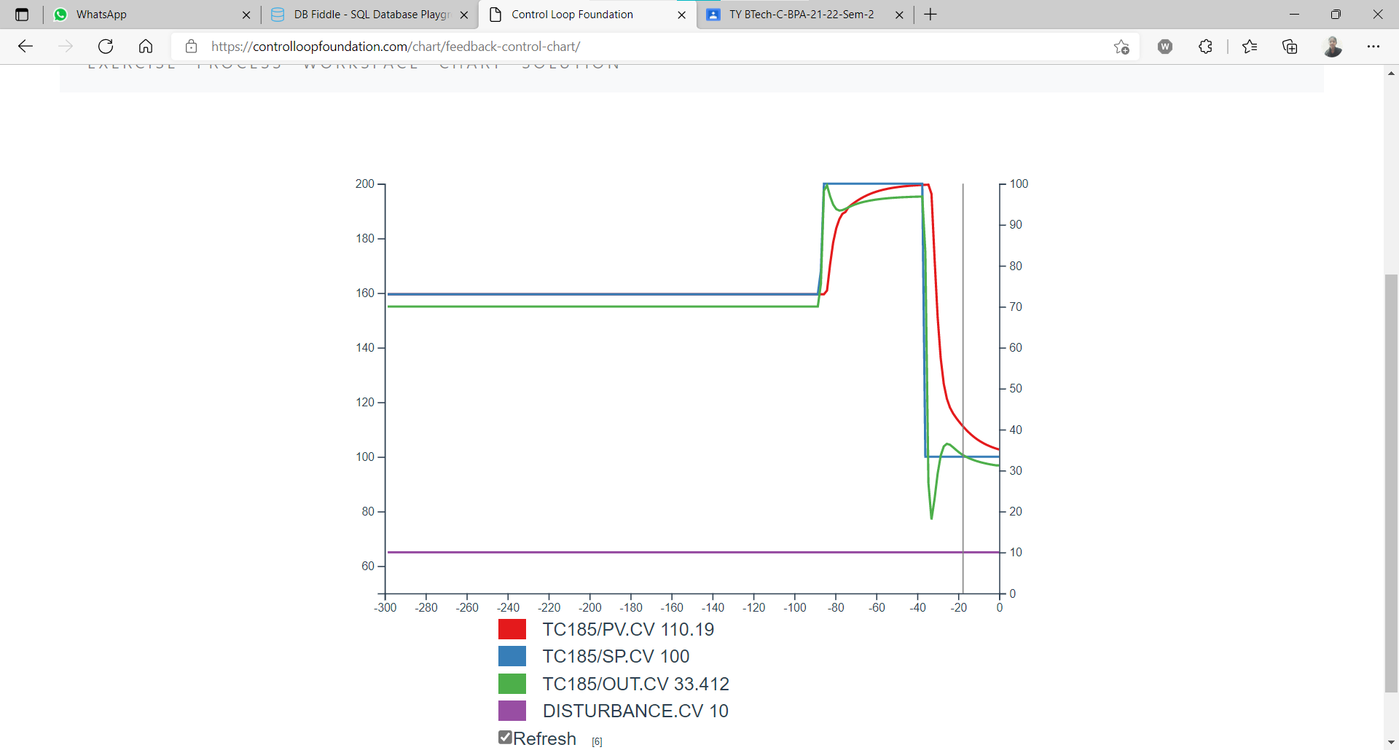

Task 4:- To comprehend how PID controller respond to the disturbances : Process load change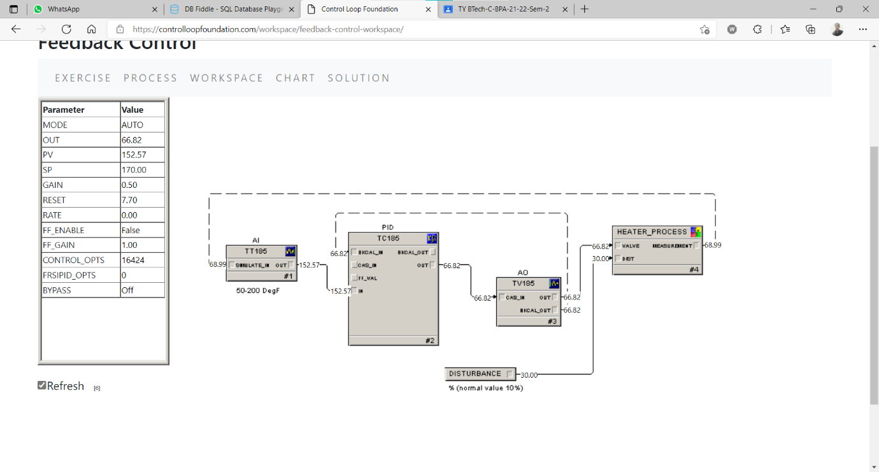

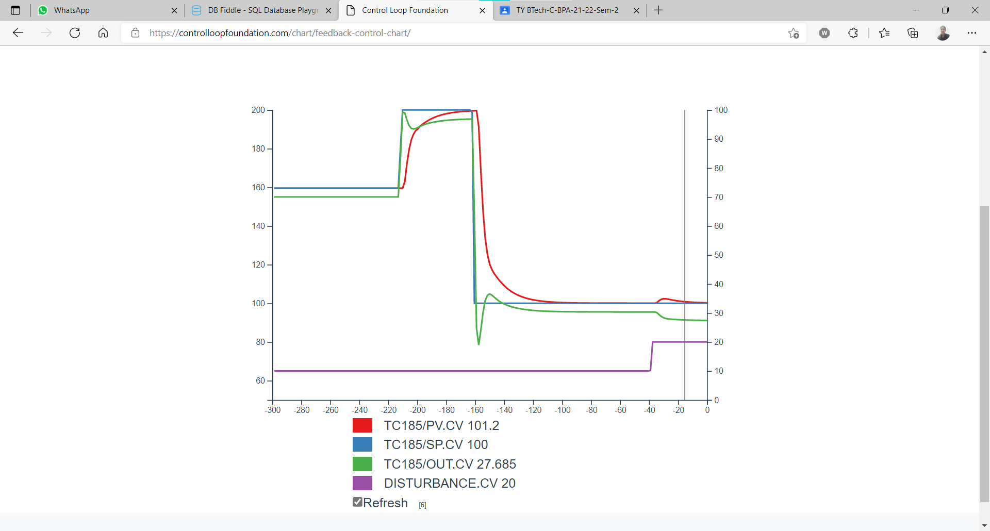

Task 5:- To comprehend how PID controller tuning respond to the disturbances : Setpoint change, Process load change

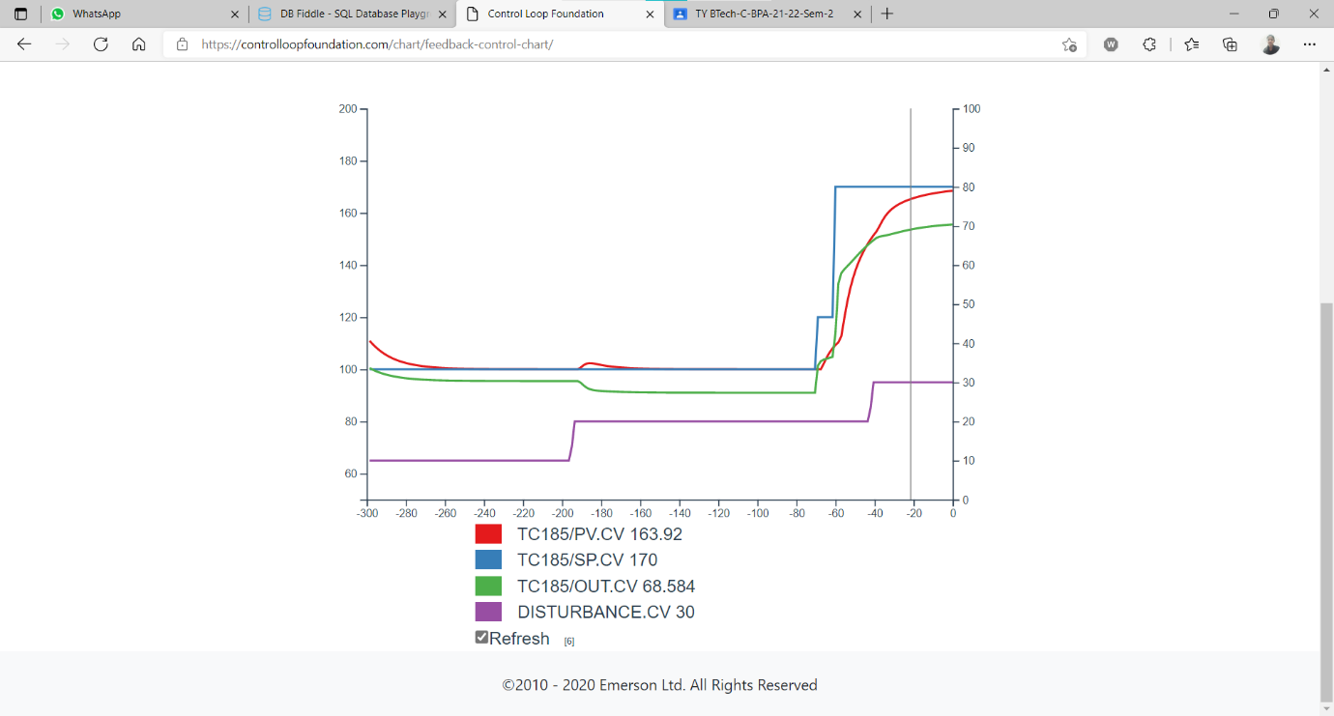

**Conclusion-**

* Learn and understand how the pid controller works in manual and auto mode.
* Learn and understand how PID controller responds to the disturbances: Set point change, Process load change.
* Learn and understand how PID controller tuning respond to the disturbances: Set point change, Process load change.